CO227::Computer Engineering Project – Report

Mic Anywhere

Chathuranga D.M.S. (E/13/043)

Gajanayake H.U.P. (E/13/106) Sandeepa A.M.H. (E/13/319)



**http://www.ce.pdn.ac.lk**

Department of Computer Engineering

Faculty of Engineering

University of Peradeniya

Peradeniya 20200

**Abstract**

In conferences, seminars when the audience is asked to question the presenter or share some ideas, distributing the microphone is sometimes a difficult task.

This mobile application will solve the problem giving the feature to use mobile phone as a microphone which is connected to wireless network.

**CONTENTS**

Abstract i

Contents ii

List of figures iii

**CHAPTER 1** INTRODUCTION  **1**

**CHAPTER 2** RELATED WORK  **2**

**CHAPTER 3** OBJECTIVES AND SCOPE  **4**

**CHAPTER 4** METHODOLOGY **5** 4.1 OVERVIEW 5

4.2ACHIEVEMENTS 6

**CHAPTER 5** CONCLUSION **7**

**References**  **8**

**LIST OF FIGURES**

Figure 2.1 Crowd Mics application interface 2

Figure 2.2 Bruno Microphone app 3

Figure 2.3 Microphone Pro app 3

Figure 4.1 Socket Connection 5

Figure 4.2 Set up diagram 6

**CHAPTER 1**

**INTRODUCTION**

In conferences and seminars when the audience is asked to question the presenter or share some ideas distributing the microphone is sometimes a difficult task. In some cases the organizers have to keep 2,3 people just to occupy the microphone and distribute as needed. This mobile application will solve the problem giving the feature to use any mobile phone as a microphone which is connected to wireless network. Anybody who has the application installed can use his phone immediately without waiting for a microphone.

This application consist of real time audio transferring technology with negligible delay. The android app is connected to the conference room wi-fi network and this uses broadcasting technology such that presenters’ ip address can be anonymous. Even though the audio sound is broadcasted not everybody can access it. A key is displayed by the presenters’ desktop app and it ensures that only the people inside the conference room can access it. The sound transferring well tuned such that the delivered audio quality is up to standard. The delivered speech is very clear because the noise reduction tech is applied and background echo is handled by this app. This app is simple, user friendly and runs on an attractive GUI and this application supports any mobile which has android version as Jelybean, lollipop and marshmallow. The audience member can press the stop button suddenly to stop unnecessary vocal violations by others.

**CHAPTER 2**

**RELATED WORK**

David Daudelin’s app

David is a technical architect in AT & T’ Emerging Markets Group in Piano Texas. He created a new app works over wi-fi or cellular data connection to a laptop computer. The laptop is simply plugged into the speaker system in the conference room. This app transformed mobile phone in to a smart mic.

Crowd Mics

Crowd Mic is an app that turns smartphones and tablets into microphones so the audience can be heard the room’s sound system. The technology work via wifi or Bluetooth receiver. The app also offers a text comment and dial simple polling feature.

While in use the presenter has several options of how he or she allows audience members interact, including selecting a particular participant an “Open Mic ” option and the ability to mute everyone.

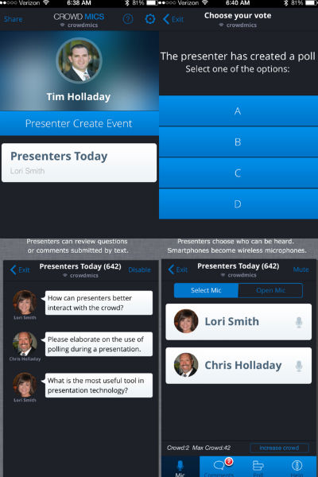

Figure 2.1: Crowd Mics application interface

Von Bruno Microphone and Microphone Pro

Both the Von Bruno Microphone and Microphone Pro are simple apps which turn iPhones into smart mics.

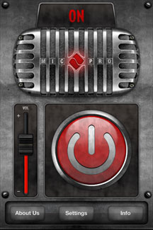

Figure 2.2: Von Bruno Microphone app Figure 2.3:Microphone Pro app

**CHAPTER 3**

**OBJECTIVES AND SCOPE**

* promote the necessity of smart mic in smart phones.

With the modern technology, questioning the teacher is one way of learning. Therefore in the conferences, seminars and class room when the audience have to ask question from the presenter this smart mic can be very beneficial. Then channelling the people who has demand for this kind of application must be needed. At the start compelling the people who are in the university is the first task.

* design and develop a android app with compelling user interface.

Want to design a application easy enough to handle for novice users and without getting boring for experienced users. The designed app interface must include these properties.

* + - * + **easy to use.**

If the audience can’t easily use the app, then they certainly won’t download app in first place.

* + - * + **app design must be goal-driven design.**

Want to design app for the right user.

* develop a desktop application with descriptive and user friendly GUI.

Desktop application use the presenter. Then its’ interface has to be easy to work with and less confusion. Presenter may has all the authority to handle the discussion or questions session. Therefore pressing one button he may has to start or stop the session. Also app has to be include all the details presenter should know like number of clients waiting for ask questions.

**CHAPTER 4**

**METHODOLOGY**

**4.1 OVERVIEW OF METHODOLOGY**

* **CONNECTING METHODOLOGY**

To use this mobile application mobile and the desktop computer should be connected to the same wifi network .After pressing the start button Java application opens an extra socket for connecting and it runs on a separate thread such that every speaker up to 10 members can connect .So that the performance is increased up to a certain level.

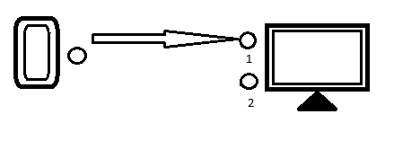

Figure 4.1 Socket Connection

* **Transferring Methodology**

Next button in the java application allows the immediate available user which is connected to transfer the data .Sound tuning is done by sampling the audio stream to 16 bit samples .sample rate is set to 16000 bps and received audio stream is saved into an 1280 byte array .This implementation improves the audio quality of the audio stream.

Big Endian variable is set to false to cut down unnecessary sounds that are inaudible to human beings .This also improves the quality of the audio stream. Java application uses a separate socket which runs on a separate thread. This separates the data transferring and the connecting in to two completely different processes.

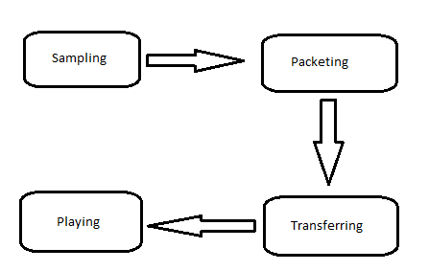

Figure 4.2 Set up diagram

* **Sampling :** Using the android mobile microphone recording audio signal into byte array.
* **Packeting :** Recorded byte array is divided into small samples.
* **Transferring :** Sampled packetsare sent through the socket.
* **Playing :** Received packet is played by a data line in the computer.

**4.2 ACHIEVEMENTS**

* + - 10 members can connect in the waiting list.
    - Playback audio quality is high.
    - Noise cancelled audio is delivered.
    - Connecting without using IP addresses.
    - Security is ensured by using a passcode.
    - Real time audio transferring with negligible delay.

**CHAPTER 5**

**CONCLUSION**

when the audience is asked to question the presenter or share some ideas, in a seminar ,distributing the microphone is sometimes a difficult task.This mobile application will solve the problem giving the feature to use mobile phone as a microphone which is connected to wireless network. This delivers realtime speech with a quality sound .Noise cancellation is applied to the delivered speech.stop feature is available for the android user to stop the unnecessary vocal violation by the others.security is ensured by the random password generator.

**REFERENCES**

[1] <http://aztechbeat.com/2014/03/startup-crowd-mics-phone-wireless-mic/> [15/12/2016]

[2] <http://www.njit.edu/features/alumni/smart-mic.php> [15/12/2016]

[3] <http://ccnmtl.columbia.edu/enhanced/solutions/iphone_into_simple_pa_system.html> [15/12/2016]